**Step 1: Create a Virtual Machine Without a Public IP Address**

1. **Log into Azure Portal**:
   * Go to the [Azure Portal](https://portal.azure.com/) and sign in.
2. **Create a Resource Group (if needed)**:
   * Click on **Resource groups** in the left-hand menu.
   * Click **+ Create**.
   * Fill in the required details (name, region) and click **Review + Create**, then **Create**.
3. **Create the Virtual Machine**:
   * Click on **Create a resource** > **Compute** > **Virtual Machine**.
   * Fill in the required details:
     + **Subscription**: Choose your subscription.
     + **Resource Group**: Select the resource group you just created or an existing one.
     + **Virtual Machine Name**: Give your VM a name (e.g., MyVM).
     + **Region**: Choose the desired region.
     + **Image**: Select the operating system (e.g., Ubuntu Server).
     + **Size**: Select an appropriate size for the VM.
     + **Authentication Type**: Choose between SSH public key or password.
   * **Networking**:
     + **Virtual Network**: Either create a new virtual network or select an existing one.
     + **Subnet**: Choose the default subnet or create a new one.
     + **Public IP**: Select **None** (to create a VM without a public IP address).
     + **NIC Network Security Group**: Select **Basic** or **Advanced** based on your requirements.
   * Configure other settings as necessary, then click **Review + Create** and **Create** to deploy the VM.

**Step 2: Create a Bastion Host**

1. **Create the Bastion Host**:
   * Go back to the **Resource group** that contains your VM.
   * Click on **+ Add** and search for **Bastion**.

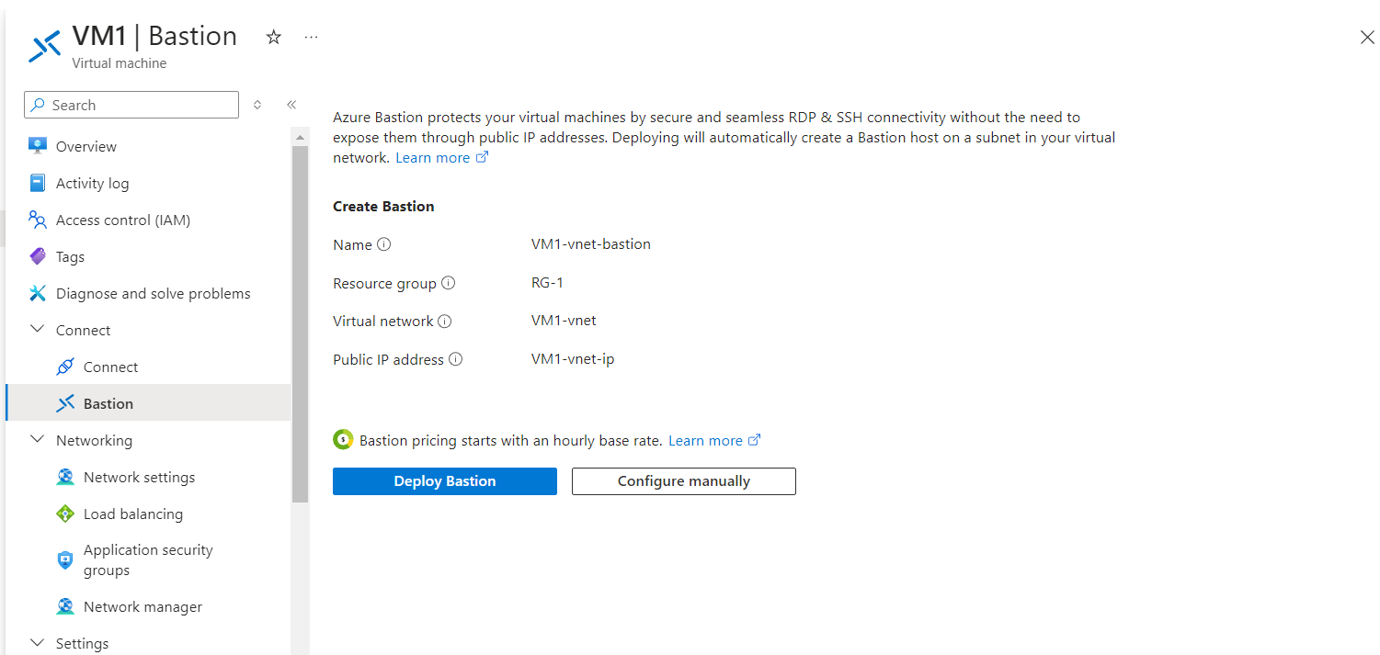

* + Select **Bastion** and click **Create**.
  + Fill in the required details:
    - **Subscription**: Choose your subscription.
    - **Resource Group**: Select the same resource group as your VM.
    - **Name**: Give your Bastion host a name (e.g., MyBastionHost).
    - **Region**: Ensure this is the same region as your VM.
    - **Pricing Tier**: Choose the appropriate pricing tier.
    - **Public IP**: A public IP will be created for the Bastion host. You can either create a new one or use an existing IP.
  + Click **Review + Create**, then **Create** to deploy the Bastion host.

**Step 3: Connect to the VM Using Bastion Host**

1. **Navigate to the Bastion Host**:
   * In the Azure Portal, go to the resource group that contains your Bastion host.
   * Click on the Bastion host you created.
2. **Connect to the VM**:
   * In the Bastion host overview, click on **Connect**.
   * A connection panel will appear; fill in the following:
     + **Username**: Enter the username you specified when creating the VM.
     + **Password**: Enter the password (if using password authentication) or provide the SSH key (if using SSH key authentication).
   * Click on **Connect**.
3. **Access the VM**:

